ASSIGNMENT 1

**Aim:**

To create a Free Tier account in AWS

**Step 1:** I have created a root account under my name

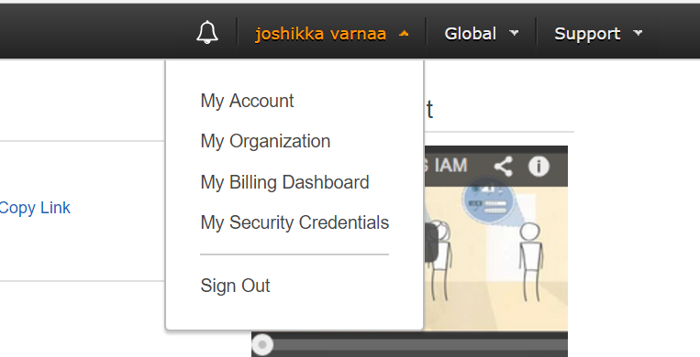

AWS Free Tier account has been created.

**Step 2:** I have created a AWS IAM user “josh”

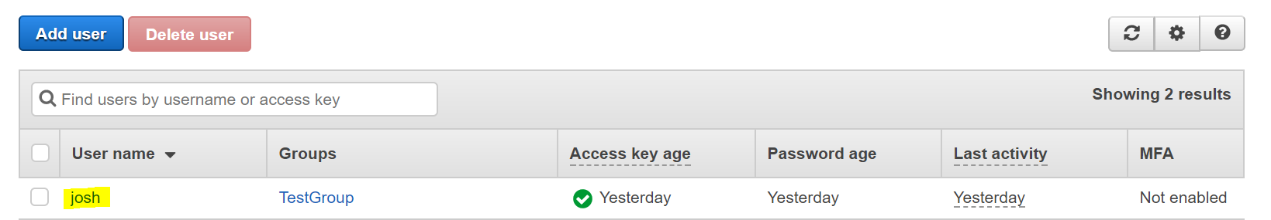

Attached the group policy to the user

